Design notes for <Design2\_TwoBoardPogoPin>

**Designer contact: Jacky Li,** [**jackymengyangli@uchicago.edu**](mailto:jackymengyangli@uchicago.edu)

Over All schematics:

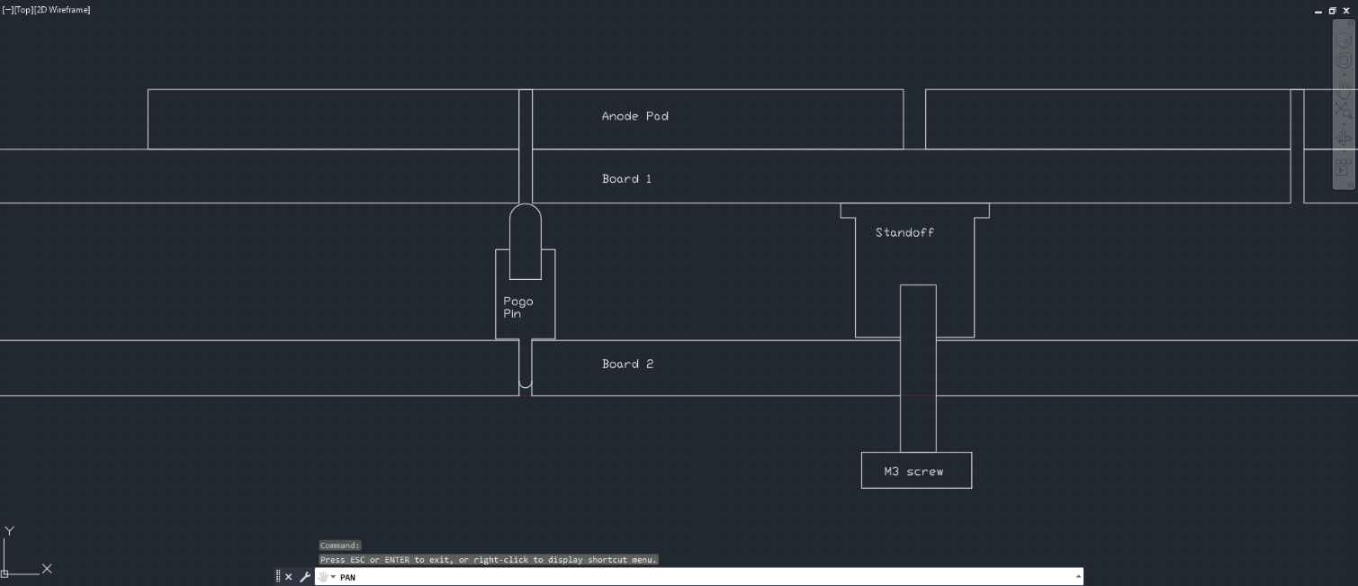

Board general info:

Board 1 has the anode pad and standoff, no ground planes. 2 layers.

Board 2 has the samtech connectors, pogo pins, and the ground planes. 4 layers because we need specific distance of ground to trace to keep the impedance of the trace 50 ohm, and we want it to have some thickness so when it is pushed and screwed on to board 1, it does not bend.

Distance between the board had been simulated by Paul and Jin, desired to be ~4mm.

**Component Choice:**

Pogo Pin details:

* Desired Length: ~4mm
* Product:
  + [Mill-Max 0906 SPRING-LOADED PIN WITH A STANDARD TAIL](https://www.mill-max.com/products/discrete-spring-loaded-pins/spring-loaded-pin-with-standard-tail/0906?s_term=0906&s_type=Quick%2FProduct%2FPart+Number+Search)
  + Part number: 0906-3 (to match the choice for spacer)
  + Part detail:
    - Length: 0.217in = 5.5mm
    - Mid Stroke: 0.0275in = 0.7mm
    - So the length at mid stroke is 4.8mm, full stroke is 4.1mm

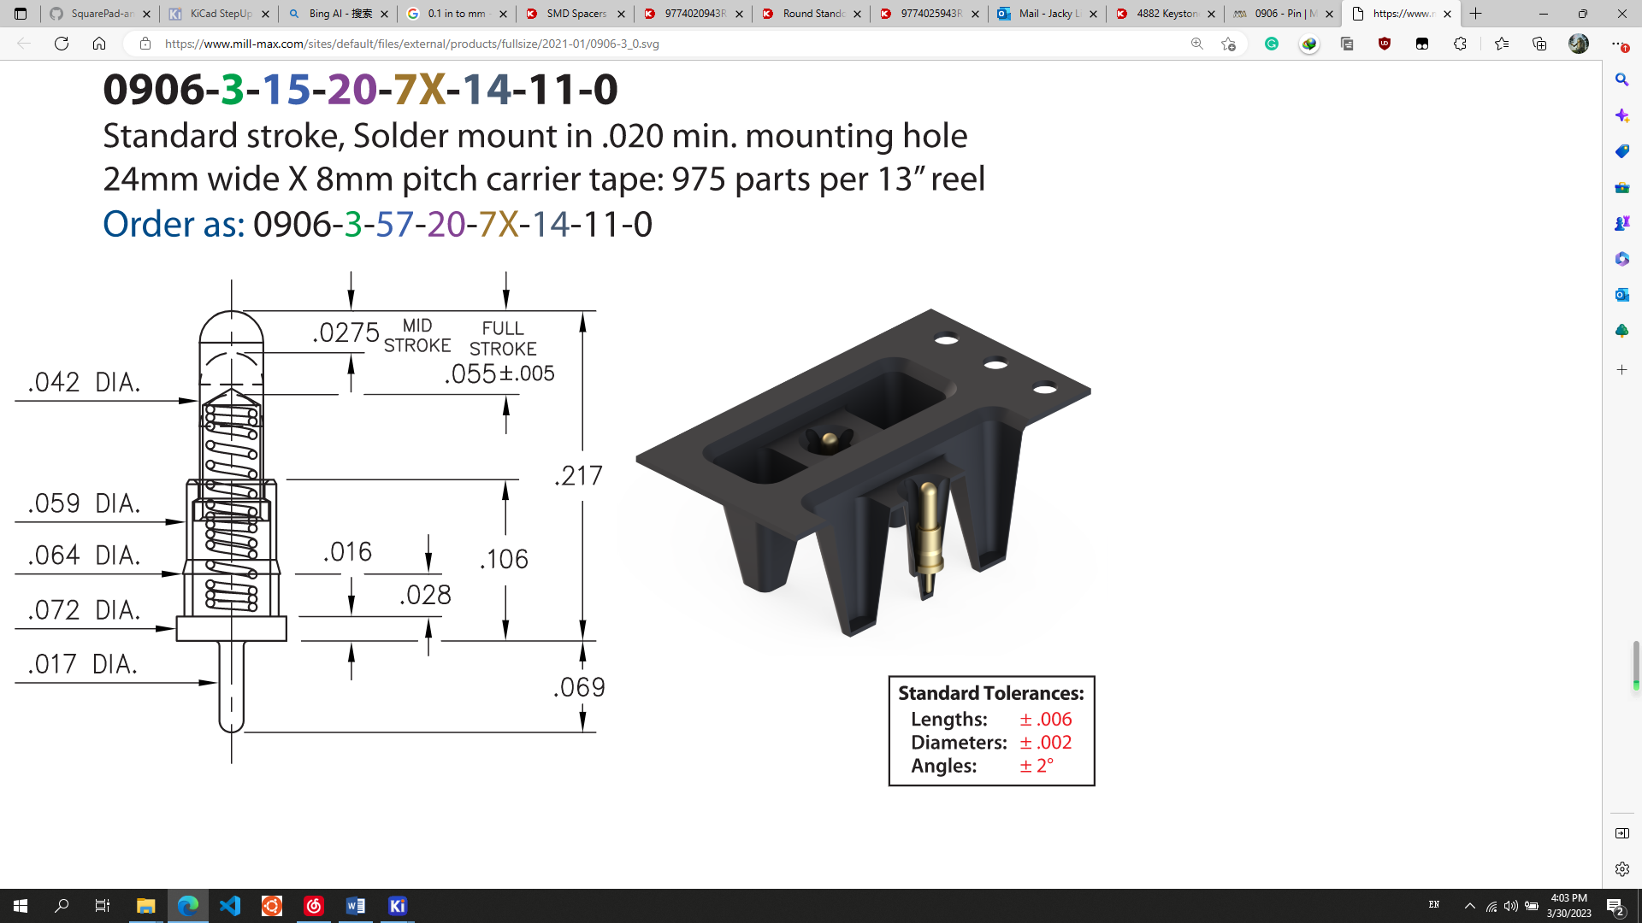

Surface Mount Standoff:

Part number: 3SSB-4.5. That uses a M3 screw.

The equivalent 4-40, that part number is SSB-4.5（ 4-40）

From this company: Mac8

This link for drawing: [https://mac8usa.com/wp-content/uploads/2022/02/en\_2022a\_rev\_ssb-series.pdf](https://urldefense.com/v3/__https:/mac8usa.com/wp-content/uploads/2022/02/en_2022a_rev_ssb-series.pdf__;!!BpyFHLRN4TMTrA!7msMJdRshhAGy-zZzV8nyRVRJcH4QOGeDg4x_iG_1Nj0PqXUWkQxGDvd-eXi7NFWSiGppI2_3Udz9fBOAiJDClTxMcTq$)

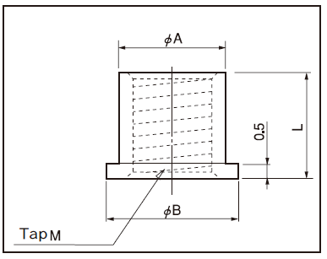

A = 4.0, B = 5.0, L = 4.5 mm

C:\Users\Jacky Li\Documents\WeChat Files\wxid_wz608g6pf8pt11\FileStorage\Temp\1684771555230.png

SMA connector:

[142-0711-271 Cinch Connectivity Solutions Johnson | Connectors, Interconnects | DigiKey](https://www.digikey.com/en/products/detail/cinch-connectivity-solutions-johnson/142-0711-271/11205991)

